楽しい英文読解教室 *Let’s enjoy reading an English story!*

|  |
| --- |
| HAPPINESS IS LOTS OF CANDLES. |

Charles M. Schulz 1965

01 Happiness is a new bicycle.

02 Happiness is a pile of leaves.

03 Happiness is a camping trip.

04 Happiness is three friends in a sandbox ... with no fighting.

05 Happiness is an umbrella and a new raincoat.

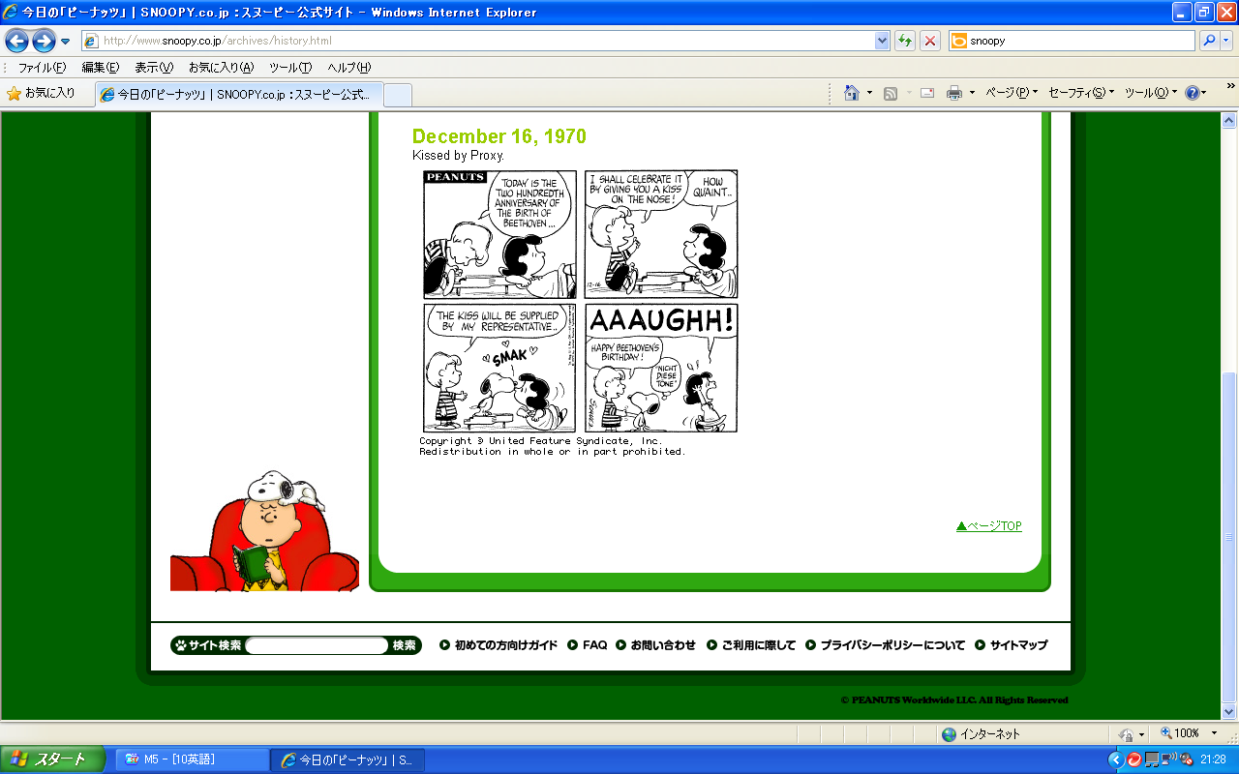06 Happiness is a warm puppy.

07 Happiness is a favorite picture book.

08 Happiness is an " A " on your spelling test.

09 Happiness is twenty-four different colors.

10 Happiness is a thumb and a blanket.