楽しい英文読解教室 *Brazilian Hero, Pele*

１　次の文はサッカー選手ペレについて述べたものである。これを読んであとの問いに答えなさい。

-------------------------------------------------------------------------------------------------------------------------------------

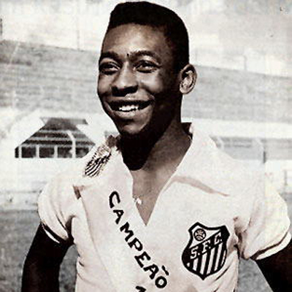All young boys in Brazil love soccer. When I visited Brazil, I saw many boys in the back streets. They were often playing with a ball. I heard their shouts even in the rain.

Many boys in Brazil want to play professional soccer. Pele is their hero.

When he was a young boy, Pele was poor. He and his friends didn't have a soccer ball. So they made their own ball and played with it.

In 1955, he became a professional player. After a few years, he became famous all over the world. When he was playing, many people stopped work and watched him on TV.

Pele became a top soccer player. But he didn't forget his poor days.

He often worked for the poor children of Africa and Latin America. Pele gave them hope for the future.

Today people play soccer in over 140 countries. It is very popular in Japan, too. For Brazilians, soccer is not just a game. It is a part of their life.

--------------------------------------------------------------------------------------------------

（注） back streets 裏通り / shout 叫び声 / professional プロの / hero　英雄　　　 forget 忘れる / hope 希望 / Latin America ラテンアメリカ

Brazilian ブラジル人　/ a part of～ ～の一部

１　次の(1)～(3)の問いに答えて，それぞれあてはまる英文を抜きだして書きなさい。

(1) ブラジルの子どもたちが我を忘れてサッカーに熱中している様子を，一番よく表している文をひとつ抜き出して書きなさい。

(2) ペレの貧しかった少年時代を象徴するエピソードを紹介している部分を，９語または10語で抜き出して書きなさい。

(3) ペレの人気のすごさを表している部分を，９語で抜き出して書きなさい。

２　次の英文は，上の文章を要約したものである。１～７にあてはまる最も適切なもの　　　を，下のア～コの中からそれぞれ１つずつ選び，記号で答えなさい。

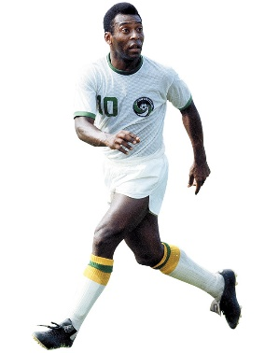Many boys in Brazil （ 　1　 ） soccer. They always play soccer. They want to （ 　2　 ） professional soccer players.

Pele was the （ 　3　 ） popular soccer player among them. Pele （ 　4　 ） to play professional soccer in 1955. He became famous. But he didn't forget his poor days. He often （ 　5　 ） the poor children of Africa and Latin America.

Today soccer is （ 　6　 ） all over the world. In Japan soccer （ 　7　 ） become very popular.

|  |
| --- |
| ア going イ most 　　ウ played 　　エ on 　オ began  カ be 　　　　キ love 　　 ク helped 　　ケ want 　コ has |

|  |  |  |  |  |  |  |
| --- | --- | --- | --- | --- | --- | --- |
| １ | ２ | ３ | ４ | ５ | ６ | ７ |
|  |  |  |  |  |  |  |

３　ＴｏｒＦ　１（　　）　２（　　）　３（　　）　４（　　）　５（　　）

４　本文の意味を確認しよう。

|  |  |
| --- | --- |
| All young boys in Brazil love soccer. When I visited Brazil, I saw many boys in the back streets. They were often playing with a ball. I heard their shouts even in the rain.  Many boys in Brazil want to play professional soccer. Pele is their hero.  When he was a young boy, Pele was poor. He and his friends didn't have a soccer ball. So they made their own ball and played with it.  In 1955, he became a professional player. After a few years, he became famous all over the world. When he was playing, many people stopped work and watched him on TV.  Pele became a top soccer player. But he didn't forget his poor days.  He often worked for the poor children of Africa and Latin America. Pele gave them hope for the future.  Today people play soccer in over 140 countries. It is very popular in Japan, too. For Brazilians, soccer is not just a game. It is a part of their life. | ブラジルの少年はみんなサッカーを①（　　　）います。私がブラジルを訪問したとき，裏通りで多くの少年たちを見ました。彼らはよくボールで遊んでいました。雨の中で彼らの大きな歓声を聞きました。  ブラジルの多くの少年がプロのサッカーをしたいと②（　　　　　　　　）。ペレは彼らの英雄です。  ペレは小さいころ，貧乏でした。彼や友だちはサッカーボールを持っていませんでした。だから自分たちでボールを③（　　　），サッカーをしました。  １９５５年に，ペレはプロの選手になりました。数年後，彼は④（　　　　　　）有名になりました。彼がプレーしているとき，多くの人々が仕事の手を止め，テレビで彼を観ました（応援しました）。  ペレはトッププレーヤーになりました。しかし彼は貧しかった日々のことを⑤（　　　　　）でした。彼はよくアフリカや中南米の⑥（  　　）のために活動しました。ペレは彼らに将来の⑦（　　　　）を与え続けました。  今日１４０カ国以上でサッカーがプレーされています。日本でも人気があります。ブラジルの人々にとってサッカーは単なるゲームではありません。それは⑧（　　　　　　　　）なのです。 |

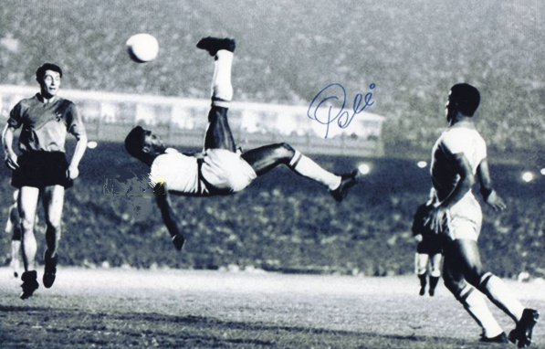

T or F

1. In Brazil, boys didn’t play soccer on rainy days. (F)

2. When he was a young boy, Pele didn’t have a soccer ball. (T)

3. In 1955, Pele became famous all over the world. (F)

4. Many people stopped their work to watch Pele’s play on TV. (T)

5. For Brazilians, soccer is a part of their life. (T)