Pictures – The Way to Reconstruction
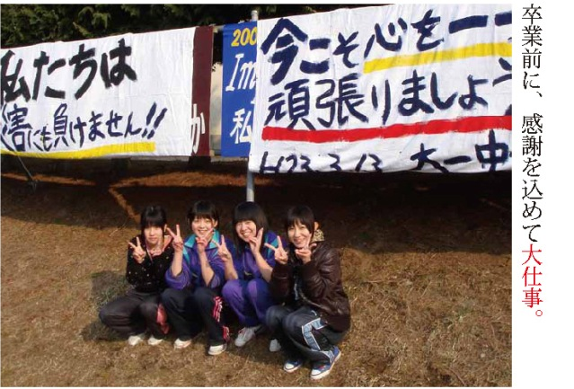
2011.03.13 Before their graduation, students made posters to express their gratitude.
Ofunato Daiichi Junior High School, Iwate prefecture, is in the area attacked by the huge tsunami. Four students of the school made big banners only two days after the tsunami.
They said, “We’ll never be beaten by the disaster” and “Let’s get together”.
I believe that there were many people encouraged by the banners.
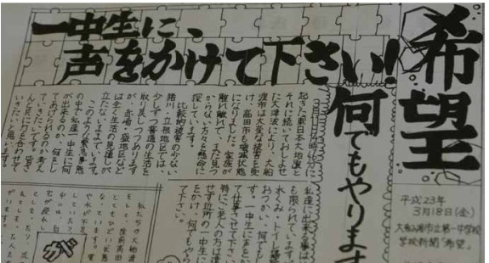
2011.03.18 Students of Ofunato Daiichi Junior High School wrote the newspaper named “Hope”.
It was made a week after the East Japan Great Earthquake.
It said, “We will do anything for people in need. Please talk to us, junior high school students. We want to be your help anytime.”
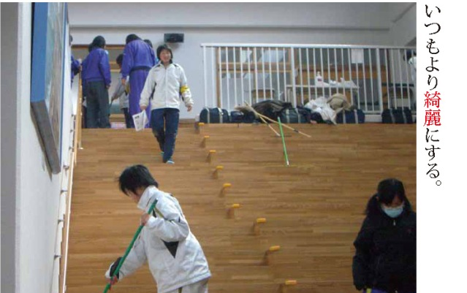
2011.03.28 Make it cleaner than usual.
Students of Ofunato Daiichi Junior High School cleaned the shelter voluntarily at Sakari Elementary School, where many people had to live together.
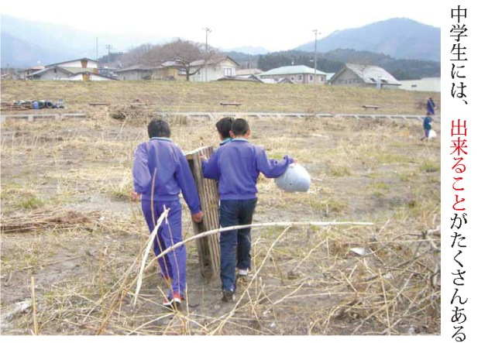
2011.04.11 JHS students can do many things.
JHS students cleaned the bank of the Sakari River in Ofunato city. The great tsunami carried a lot of rubble there. Although the step was small, it seemed to give us hope to the future.
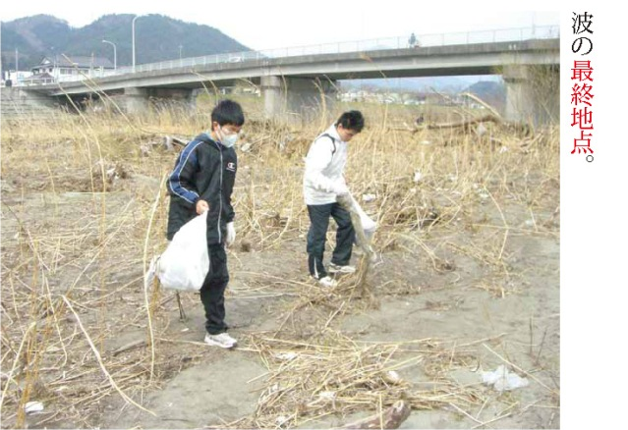
2011. 04. 11 The furthest point where the tsunami reached.
JHS students cleaned the river in Sakari town. It got difficult to find the rubble when they reached to the mountainous area.
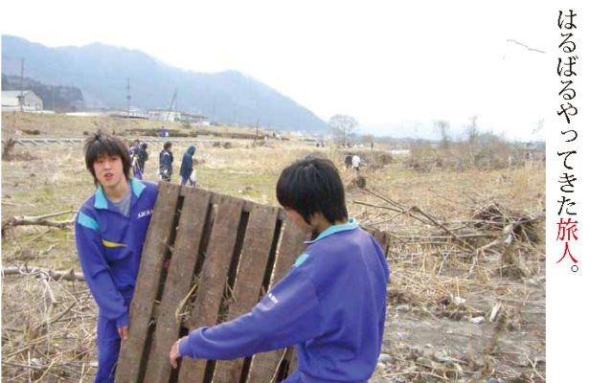
2011. 04. 11 A voyager from far away.
The students found a wooden pallet at the bank of the Sakari River when they cleaned there. The pallet was so heavy that two students could carry it with difficulty. Did the pallet make a voyage from the Bay of Ofunato, 3 kilometers far away?

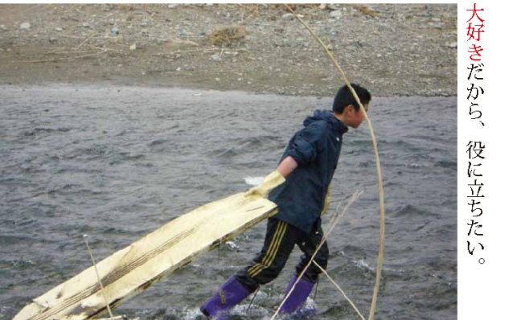
2011.04.11 I love my town, so I want to help.
Many students worked around the banks of the Sakari River in Ofunato city. They said, “We will always do the best for Ofunato. Please make use of our powers.”
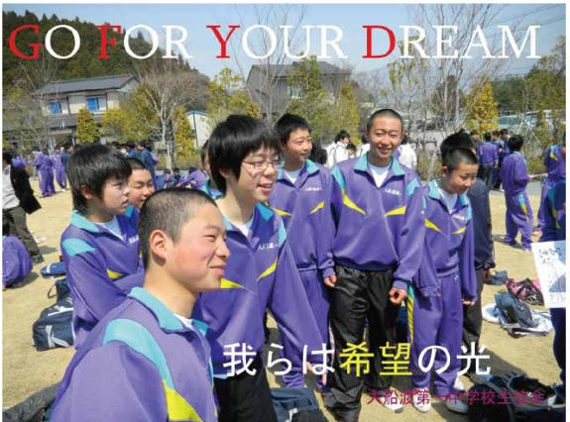
2011.04.13 We are the lights of hope.
The poster made by Ofunato Daiichi JHS said, “We create the future of Ofunato.”
After the Great Earthquake, all the students gathered for the first time and sang the chorus for the refugees at the Rias Hall.
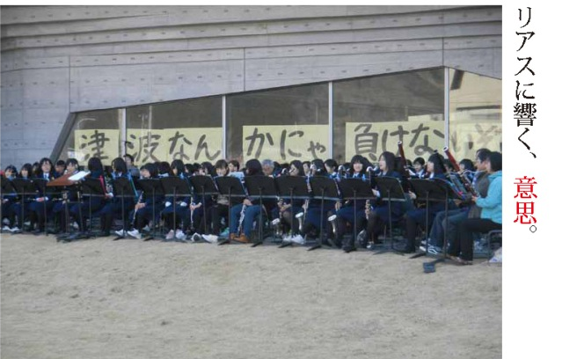
2011.04.17 The sounds of Will at the Rias.
At the Rias Hall, one of the shelters in Ofunato city, the civil group composed by all ages from students to adults played music. May the music give a big power to people.

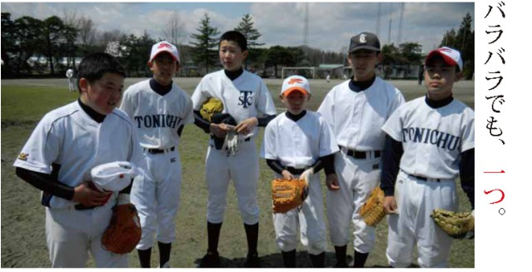
2011.04.24 Although we are in various uniforms, we are one.
The baseball team of Touni Junior High School in Kamaishi city, Iwate prefecture. They played baseball in practice games. They wore various uniforms sent from all over Japan.
The results are 11-0, 4-2. The new team won in both the 2 games. They looked different, but they all had the same pride of ‘Touni baseball’.
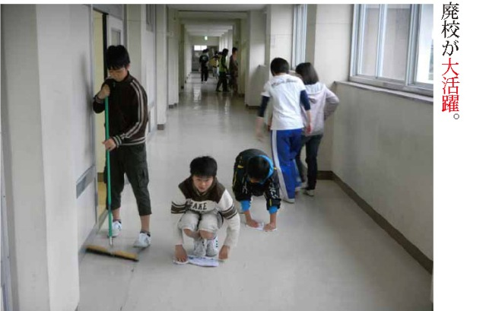
2011.05.13 A closed school will work again.
All the people of Okuma town have moved to Aizuwakamatsu city. Okuma Junior High School was going to start again in a closed school there. The students cleaned the school building before classes would start.

2011.05.19 We found a big smile.
A shot at Kamaishi Higashi Junior High School, titled " Search for something like a face." The students made a big smile by themselves.
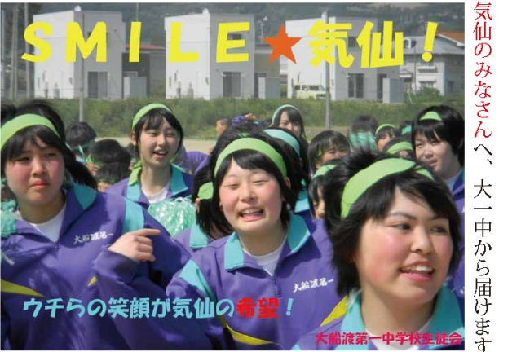
2011.05.26 To everyone in Kesen, we send our smiles from Daiichi JHS.
A shot during the practice for the athletic meeting at Ofunato Daiichi Junior High School. “Every student in the picture showed a wonderful smile. So we made this poster”, school staffs said.
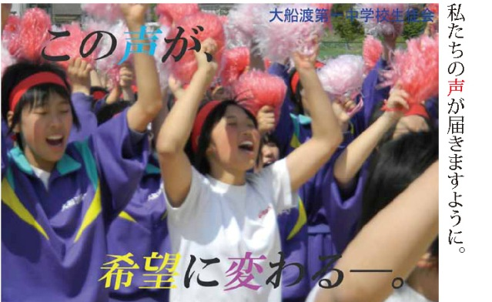
2011.05.26 May our voice reach you.
Ofunato Daiichi JHS have made posters with messages after the Great Earthquake.
This is a shot during the practice for the athletic meeting. This year, the theme of the meeting was "Reconstruction".
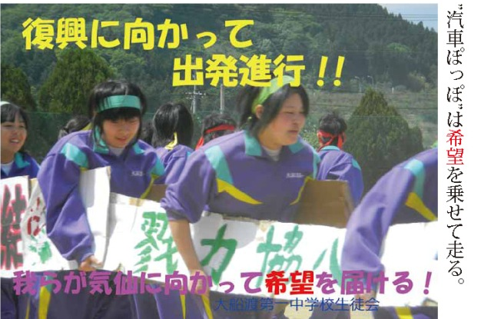
2011.05.26 Kisya Poppo runs with hopes.
This is a shot of the event Kisya Poppo, 'The steam locomotive' in the athletic meeting. There is a strong message from the students in the poster. 'Let's send our hopes to Kesen'. May our hopes reach Kesen, Iwate, and Japan.
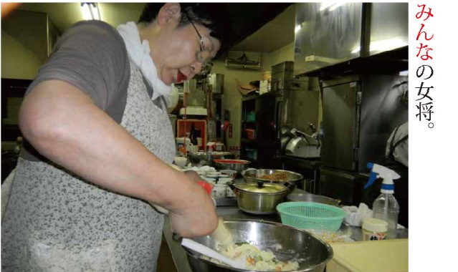
2011.06.23 'The landlady for everyone.
Ms. Shimizu, the landlady of the inn Rakuzan in Bandaiatami hot springs. The day before the refugees of the inn moved to their temporary housings, she made many sandwiches for them. Children, who stayed there for a long time, had watched her making them until she finished.

